HOW TO CLAIM A RIGHT OF WAY WITH EVIDENCE OF USE

WHY WRITE THIS GUIDE?

Having spent time researching lost rights of way I found that there were many times when it was simpler to claim a right of way by asking people for evidence that they had used the route.
But I was frustrated that there did not seem to be a guide that set out the nuts and bolts and practicalities of how to make a claim.
This guide is the result. It does not try to cover all the law and the complexities of the system. You should contact organisations like the British Horse Society, the Open Spaces Society or the paths team of the Ramblers for that. But it does try to take you through the stages in an easily understandable way.

CONTENTS

WHY WRITE THIS GUIDE? 1
CONTENTS 1
FIRST DISCOVER YOUR ROUTE 3
IS IT ON THE MAP? 4
PUBLICLY MAINTAINED ROUTES 4
QUESTIONS, QUESTIONS 6
WHY THE DATE OF BRINGING INTO QUESTION MATTERS 6
WHEN YOU DON’T HAVE TO WAIT 20 YEARS 7
WHAT YOU ARE GOING TO DO 8
FORMS, FLIPPING FORMS 9
MAKING YOUR MAP 9
WHAT QUESTIONS SHOULD YOU PUT ON THE EVIDENCE FORM? 10
YOUR COVERING LETTER. 12
WHERE ARE YOUR WITNESSES AND HOW DO YOU CONTACT THEM? 14
HOW MANY WITNESS FORMS DO YOU NEED? 15
WHAT KIND OF USE DOES NOT COUNT 15
WHO WILL MAKE THE APPLICATION AND HOW DO YOU DO IT? 16
WHO? 16
HOW? 16
AN APPLICANT’S STATEMENT OR COVERING LETTER? 16
MAKING THE APPLICATION 18
TELLING THE OWNER AND OTHERS 19
WHAT HAPPENS NOW 21
APPENDIX 1, AN EXAMPLE OF A WITNESS FORM AND COVERING LETTER WHERE APPLICANTS MUST DRAW THE ROUTE THEY USED. 22
APPENDIX 2, EXAMPLE OF A FORM AND LETTER WHERE THE ROUTE HAS NOT CHANGED 26
APPENDIX 3, AND EVEN SHORTER FORM USED WHERE THE ROUTE IS NOT IN DOUBT 30
APPENDIX 4 AN APPLICATION FORM 31
APPENDIX 5- A NOTICE THAT YOU CAN USE TO TELL LANDOWNERS ETC. 33
APPENDIX 6 A CERTIFICATE OF SERVICE 34

FIRST DISCOVER YOUR ROUTE

(I use the term route to describe a footpath, bridleway or restricted byway)
This may sound a bit odd, but most of us travel on paths and tracks without wanting to add them to the rights of way map. Usually the issue comes up for one of these reasons:
- A sign goes up saying something like “private”, or” no right of way” or “permissive route only”.
- Someone tells you or a friend that you should not use the route or tries to turn them back.
- The route is obstructed by a locked gate or something else.
- You become aware of a potential planning application which would involve building over your route.
In these cases you must act straight away or accept the loss of the path. This is because you will have to show evidence of use of the route up to the time that one of these things happen.
Of course, in the case of a planning application, if you delay taking action you may find your route has been built on! (Where there is a planning application you must ALSO object to the application mentioning your route.)
Alternatively:
- You may simply become aware that a route you walk or ride is not on the rights of way map.
In this case you should be a bit cautious. A landowner might be happy to let people use the route at the moment, but may change their mind when confronted by a formal application. It is also harder to get people to give evidence if there is no threat to a path. On the other hand, recording the route makes it secure. This is more likely to be an issue if the land owner is a private individual rather than a large organisation such as a council, or a utility company.

IS IT ON THE MAP?

What you are going to do is to try to get the route on the definitive map and statement, which is the legal record of rights of way.
So the first thing to do is to double check whether or not it is already on the map. All highway authorities (in rural areas of England the county council) must maintain a map and statement. Many of them put a version of the map online.
The West Sussex map is here.
The East Sussex map is here
The Brighton and Hove map is here
Alternatively rights of way are shown on Ordnance Survey explorer and landranger maps, but the latest changes will not be shown and the landranger map sometimes misses off short rights of way.
If the route IS on the rights of way map then you do not need to add it! (unless the route is used extensively by horse riders and/or cyclists but only on the rights of way map as a footpath). Instead report the problem to the council’s rights of way team.
In West Sussex do this here
In East Sussex do this here
In Brighton and Hove do this here
Alternatively you can report a problem in most areas of the country using Fix My Street

PUBLICLY MAINTAINED ROUTES
There are also a number of paths and alleys in urban areas and rural routes which are not on the rights of way map. For example there are a thousand such routes in Eastbourne alone.
This is because when the first rights of way maps were drawn up it was not thought necessary to add these to the rights of way map.
Councils maintain maps of routes that they are liable to maintain, sometimes called “maps of adopted roads” or “list of streets”
You can find a map of adopted roads in West Sussex here (click on map features) The East Sussex map is here (it is full of mistakes through). The Brighton map is here
It is unusual to find the sort of problems listed on the last page on publically maintained routes. You might feel that it is not worth trying to add them to the rights of way map although you can apply. If you do come across a problem report it to the highway team at the Council. Fix My Street is a good way to do this.

QUESTIONS, QUESTIONS

Putting up a private sign, a sign that says a route is permissive, telling someone not to use a route or obstructing the route (even for one day a year) are all ways that an owner or someone else can “bring the way into question”. This is a technical term for someone saying that there is no right of way, or asking the council to consider whether there is a right of way.
But there are other, less obvious, ways of bringing the route into question:
- A landowner can deposit a statement and map with the highway authority setting out what rights of way they admit on their land . These statements last for a set period but can be renewed. These statements must be published online by the council. You can find the current statements for West Sussex here, East Sussex here and Brighton here. Do check this. If there is a current deposited statement get advice before going any further.
- The owner can make an agreement with the highway authority or a national park to open up a route as a permissive route, where access is allowed but no right of way has been created. This can make it difficult to claim a right of way. Get advice before you go any further.
- If the route has not been called into question by any other means, it will be brought into question by you sending in an application to add the route to the map.

WHY THE DATE OF BRINGING INTO QUESTION MATTERS
Normally you are going to have to show that the route has been used by the public as if they had the right to do so continuously for a period of 20 years up to the date the route was first brought into question. So the date is vital.
There are very often huge disputes about this and it can be the most important issue in an application. You say that the route has been used for 20 years but the landowner says that they erected a private sign 5 years ago but which fell down 2 years ago. If they can prove this is the case then you do not have to give up, but your 20 years is the 20 years before they erected the sign. There may be huge questions about whether a particular gate was locked, whether or not anyone was turned back, whether a sign was erected and destroyed, and so on.
This is the reason why there are a number of questions on the form you will be asking people to fill in which are designed to find out if the path has been brought into question before.
It is also the reason why, if a private sign goes up then you need to crack on with any application, since the further back in the past you have to go the harder it is to get evidence.

WHEN YOU DON’T HAVE TO WAIT 20 YEARS

There are some cases where you do not have to go back 20 years.
If you can show that the landowner has offered the route and the public have accepted it then you only have to show that the public have used the route since it was offered. You would use the usual process but for a shorter period.
Example of this might include where a developer has offered a right of way as a condition of getting planning permission and the public has started to use it.
There are particular problems when a landowner has offered an alternative route while obstructing an existing one.
Always get advice before making this sort of application.

WHAT YOU ARE GOING TO DO

You are going to collect written evidence from witnesses- people who have used the route on foot, on horseback, or on bicycles (depending on what sort of route you are claiming)
(The rules on use by cycles are complicated. Normally cycling use is evidence of a bridleway, but at some periods it is evidence of a byway.)
You are then going to make an application to add your route to the rights of way map.
This means that you are going to:
1). Work out how to contact the people who have used the route;
2). Devise an evidence form for them to fill out, together with a covering note explaining what you are doing.
3). Get the form to them
4). Get them to fill in, sign and return the form.
5). Use the evidence to make the claim.
All this is explained in the following pages.

FORMS, FLIPPING FORMS

Most highway authorities have an evidence form that they like you to use. You must request West Sussex Council to send you copies if you want to use their form. Phone 01243 777100 East Sussex have a form that you can download here
But there are a number of reasons why you might not use the forms provided by a council:
- They are standard forms which are designed for any situation, so they are extremely long, off putting and difficult to fill in without help, which you may not be able to provide.
- They ask a number of questions that will not be relevant to your route, and may leave out questions which are.
- The council’s forms still require you to provide your own map. They ask that witnesses sign both the statement and the map, which is extra work. Since you have to provide your own map, you might as well provide your own form and put the map on it.
- People who collect information have duties under the General Data Protection Regulations (GDPR). Council forms usually have a lot of information about the council’s duties under GDPR but none about yours, which you must give.
Some people limit their forms to one sheet of A4, with room for an explanatory letter on the back. I am prepared to go to four sides of A4 including the explanatory letter.
You can find some examples of forms and covering letters in appendices 1, 2 and 3 The Ramblers has a draft form here but it does not include a map.

MAKING YOUR MAP
This is one area where you might want a few computer skills. If you are not confident find a friend who is. However the council may be able to supply a paper map if you give them the area. An alternative is to simply hand draw a map and photograph it.
You can use an ordnance survey map. A good source is Bing maps at https://www.bing.com/maps/ (There is a drop down menu top right which initially shows the word “Road”. Click on this and then select the ordnance survey map.) Alternatively you could use the council’s online rights of way map. There is usually an option not to highlight existing rights of way. Cut and paste the area you want. The Ramblers has a licence to use OS mapping. But you do not have to use an OS map.
You need to highlight the route that you are claiming so that people know where it is, but on the other hand, if there is any doubt, you are not supposed to “lead” your witness to say that they walked a certain way.
It may be useful to label the beginning and end of the route. It is usual to use capital letters A and B etc. If you are absolutely sure that the route has always followed the same course (perhaps because it has always been fenced in on either side) then you can simply draw the route on your map but if you are not sure, for example because the route goes across an open field, you need to ask people to mark on the map the route that they used. You can give them clues. For example you could use a map that shows your route as a path, without saying that this is the route, or you could highlight any gates or stiles that they might use.
It is a problem if everyone has (for example) taken a different route across a field, because your claim has to be for a linear route.
You can trace a large scale map and simply include the key features. Here is one of mine. I was claiming a route which goes across the car park at Saxonbury House from the Kingston Road to Juggs Road. Most of the potential witnesses live very locally so they would recognise all these places.
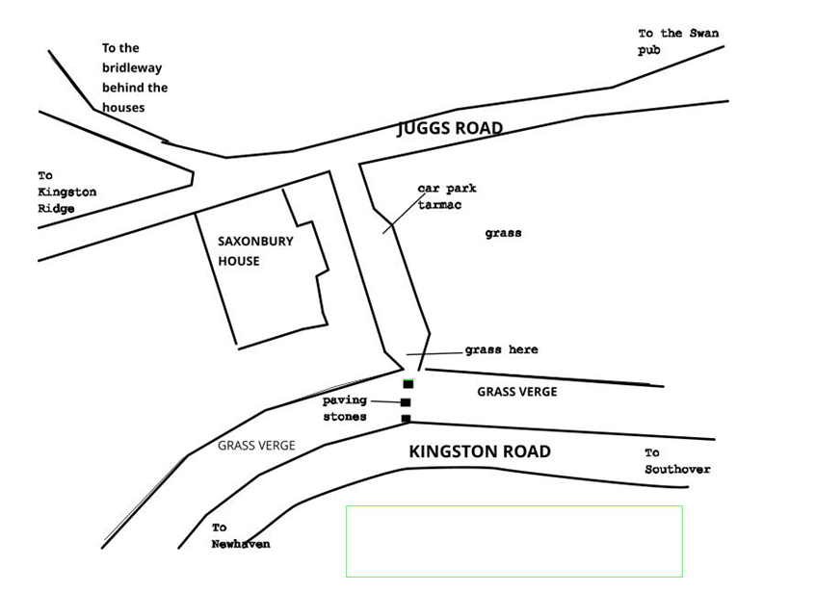
You should have the map as part of your evidence form.
Don’t forget that, even if your map is in colour, lots of people will print it out in black and white. Make sure your map looks o.k. in black and white.

WHAT QUESTIONS SHOULD YOU PUT ON THE EVIDENCE FORM?

I would always put the following in
- Please draw on the map the route you used (if you are asking people to draw on the map)
- Please give your name and address
3) If we can contact you for further information what is the best way to contact you?
4) When did you first start using the route?
5) When was the last time you used the route?
6) How often have you used the route? (e.g. weekly, monthly, once a year)
7) Did you use the route on foot/horse/bicycle/other?(unless you are sure everyone used the route on foot)
8) Have you ever encountered any stiles or gates on the route?
9) Have you ever encountered any locked gates or other obstructions?
10) What did you use the route for? (e.g. for exercise, to walk to the dog, to get to work, to get to the shop etc.)
11) Have you ever seen any notices saying that the route is private, or not a right of way or similar? (if so please give details)
12) Have you ever been asked not to use the route? (If so please give details)
13) Have you ever asked anyone for permission to use the route (if so please give details)
14) Has the route changed over time? (if so please say when and how it changed)
15) Please add any other information that you think might be significant
16) Please sign your name and put the date you signed.
17) Tell people how to return the form.
This will normally be enough. But you could also ask:
18) In principle would you be prepared to come to an enquiry about your use of the route?
Keep the whole thing on two sides of A4. See the examples in appendices 1 an,2 and 3
.
Sometimes councils object to you not using their form. If they do ask them for the legislation that says you must. There is none. They have to consider all evidence even if it written on the back of a cardboard box.

YOUR COVERING LETTER.
You need a covering letter for potential witnesses. This should tell them
- Where the route is. This is particularly important if some of your witnesses live a long way away. A map (perhaps larger than the one on your evidence form), photographs and a description will all help. People need to know the route they are giving evidence for.
- Why you are applying to add the route to the rights of way map now (for example, “The landowner, PP Head property developments has barred the route and put up private signs. We know this route has been used by many people for years and we want the route put on the rights of way map and opened again.” Or “There is currently no threat to the route but we want to safeguard it for future generations by putting it on the rights of way map”
- Who you are, in a general sense. For example “ We are members of the Hobbiton Rambling Club”
- How to return the form (even if you put this on the form itself.) Give an address and an email address. Original forms are stronger evidence, but emailed ones will do providing that they are signed. You should tell people that they should sign the forms and then scan them. If you are affluent or you are part of an organisation with a budget you could include a stamped addressed envelope. If you are prepared to collect the forms give details of how people can contact you to collect them.
- What will happen to the forms when they are returned. (For example you will send them to the council with an application to add the route to the rights of way map. GDPR means that you must also tell people how their data will be stored since it is you that is collecting it, not the council. Here is a form of words that has been agreed by Ramblers central office: A copy of the form you fill in will be kept by the Ramblers for this application only. It will not be used for anything else. It will be passed to xxxxxx County Council to process the application to add the route to the map. They might send it to the Planning Inspectorate. The evidence you have provided may be made public (minus any contact details) by the council. The Ramblers will delete their copy of your form when the path is securely on the map. You can see the policy of the county council at (insert web page where the council sets out its GDPR policy).
- That each member of a household who has used the route should fill in a form. How people can get more forms for family members neighbours and other.
If you manage to get all this on one side of A4 make sure you leave the other side blank. This way your covering letter and your form are on two different pieces of paper. People only have to return one of them.

WHERE ARE YOUR WITNESSES AND HOW DO YOU CONTACT THEM?

It can be difficult to work out who else is using the route. This is especially the case if your route is in the middle of a big town, or if it is in remote countryside.
Here are some ideas:
- If there is a settlement of houses nearby, staple the covering letter and the form together and post them through the letterboxes of the houses. Try to distribute about 100 if you can. This will probably involve a visit to the copyshop.
- If the parish council is sympathetic to walkers and other path users, ask them if they can distribute forms and covering letters or perhaps put a link on their web site.
- If at all possible, get copies of the form and covering letter on a web site. any website will do so long as you can send people links so that they can download forms.
- Ask any organisation that you are a member of that might conceivably be interested to circulate the form/letter or a link. The may have a newsletter which could include this information.
- Email every walking/riding/cycling club in the vicinity with copies of the letter/form and details of how to get more forms.
- If you or anyone you know uses social media post links to download the forms on them. Try to post on any walking/cycling/riding pages as appropriate and also any neighbourhood pages covering the area.
- If there are any times when the route is especially busy consider standing on the route and handing out leaflets. I got about 50 forms out at school pick up time on a route used by people on the way back from school.
- You could post notices on the route itself giving a link to the web site or an email for more details.
- If there is strong local feeling consider calling a meeting, or asking the parish council to call a meeting. At the meeting explain what can be done and ask people to fill in forms there and then. Print out forms and bring pens.

HOW MANY WITNESS FORMS DO YOU NEED?

The Open Spaces Society suggests 6-10 in an isolated rural area and 30 or more in a more populous area.
Personally I would try to get at least 20 forms filled in, with at least 10 forms covering any one year. So, for example, if one person used the path between 2000 and 2009 and another person used the path between 2009 and 2020 this would count as one person towards your 10. Often it is more difficult to get evidence of use for the early years of your 20 year period.
If you do not get enough forms think about other places you might find witnesses.

WHAT KIND OF USE DOES NOT COUNT
Some forms of use of a route do not count towards showing evidence of use:
- Use by force
- Secret use ( so all the times you bunked as a teenager in for a midnight party do not count)
- Use by permission- either because you personally got permission from the landowner or the landowner created a permissive path
- Use to visit or deliver to the landowner or tenant of the route or to work for them (so the postie does not get a right of way up your front path)
- Use by right (so if you have something in your house deeds that says you can use it this does not count towards claiming a public right of way)
Some of the questions on the suggested forms are designed to show up these types of use of the route. But even if a form cannot count showing public use it can show evidence of the state of the route, for example the existence or not of signs, gates and so on.

WHO WILL MAKE THE APPLICATION AND HOW DO YOU DO IT?

Once you have enough evidence forms you can make your application to add the route to the map.

WHO?
Any individual or incorporated body can make an application. That means that a parish council, an organisation like the Ramblers or the British Horse Society or you as an individual can apply, but an informal group of walkers or riders cannot apply. There must be a named individual claiming on behalf of the organisation.
In a small community an application may cause friction if the land owner is an individual in the community. In this case you might want someone else in any organisation you belong to, to make the application .
Something else to think about is that it can take many years to process an application. If an individual who has applied becomes unable to act or moves away in that time there is currently no way of transferring the application to someone else.
I normally apply, using my name, “for and on behalf of” the Ramblers or the Open Spaces society and giving the head office address. Although it is not completely certain, it is believed that this will enable someone else from the organisation to take the claim over if necessary.
If you are applying on behalf of an organisation check what rules that organisation has. There may be an authorisation process and you will probably need to send them a copy of the application, any statement and the certificate of service after you have applied.

HOW?
You have to apply using a form of words set down by the government. You can email West Sussex County Council or Brighton and Hove Council to get a form that will do. East Sussex has a form you can download here
You can find a form that meets the conditions in appendix 4.

AN APPLICANT’S STATEMENT OR COVERING LETTER?

You do not have to provide anything apart from the application and the evidence forms, but it is useful to write a short applicant’s statement. Remember that the council officer probably does not know the area, is not familiar with the area and does not yet know what the issues are.
You could briefly describe the route, say roughly how long it has been in use and (if this is the case) how the route has been called into question. If the route is threatened by a planning application say and, if possible, give the reference for the application. This will speed consideration of the route up.

MAKING THE APPLICATION

You now have your evidence form, your application and perhaps your statement.
MAKE SURE YOU HAVE COPIES OF ALL THESE, INCLUDING ALL THE EVIDENCE FORMS and keep them where someone can get hold of them if you become unable to act.
You now have to get the application to the council.
During the Covid crisis Councils have been accepting applications and statements by email. Some are accepting copies of the evidence forms by email.
Ask the Council what the relevant email address is.
But you may want to deliver paper copies and some councils may return to insisting on this.
My preference is to deliver the material to the council by hand and get a receipt for it on the desk. If you can’t do this send it recorded delivery and email the relevant officer to ask for an acknowledgement of receipt.

TELLING THE OWNER AND OTHERS

You are nearly finished, but you now have to tell the owners and any other occupier of the land that you have made an application.
Of course, the key issue is finding out who they are. You might be able to get the Council to do the work for you, but otherwise visit the Inspire map web site at https://www.landregistry-uk.com/map-search
(In mid 2022 there were reports that this was not working properly. You can also usehttps://www.landregistry-uk.com/map-search which will give you the same information.
Use the search box to focus on the area you are interested in. Land parcels are given Inspire reference numbers. There may be one or more land parcels which cover the route.
Then go to this page https://search-property-information.service.gov.uk/search/search-by-inspire-id . Type in the inspire reference. This enables you to order the land registry title.(You do not usually need the plan). You will need a credit card to pay £3 per title and an email address for the land registry to send the title document to.
The title deed will give you the address of the owner. You can cut and paste this into the notice that you will send the owner.
You may find that the address given from the owner is not the same address as the property itself. For example the property may be called “Snowflake Farm”, Petworth, but the owner may be a property company in London or somewhere else in Petworth.
If this is the case then you should also send a notice to “the occupier, Snowflake Farm, Petworth” or whatever the address of the property is. You will often have to do a search for the postcode.
As usual, there is a standard form of words that you should use in your notice. You can get form that will do the job from the council and there is also a template that you can use in appendix 5.
Sometimes you will find that the land is not registered at the Land Registry. It only became compulsory to register land when it changed hands in the second half of the 20th century and it may not have changed hands since then. If you find this case, tell the council. They will usually ask you to post notices on site.
Write out your notice as usual but instead of putting an address of the owner, put “to the owner or occupier of this land” Print 2 copies.
Take them to a print shop to be laminated, making sure you sign and date it first.
It is a good idea to punch holes in the laminated notices in case you need to tie them up with string. Take string, scissors and drawing pins in case you need them. Go to the route and post the notices in a prominent position as near to each end of the route as you can. Take a close up picture of each notice so the council can read it. Then take a second picture further away so the council can see it in context. Send these pictures to the councils with an explanation of what they are.
After you have sent out the notices and done any necessary posting on site you send the Council a notice that you have notified everybody. Leave doing this for a few days after you send any letters out to allow time for people to receive the letters.
As usual there is a form of words for this. You can get a form from your local council or use the template in appendix 6.

When you have sent in this notification you have completed the application process.

Well done!

WHAT HAPPENS NOW

Within a month of you making the application the Council must put details of it on their web site (contact details will be removed). If they don’t, chase them up.
Then prepare for a wait until the council starts to process the application, often by consulting the landowners and other interested body. This wait will be counted in years.
If they have not decided your application within a year you have the right to apply to the Planning Inspectorate for a direction to decide the application, but that is for another handout.
It is probably a good idea to contact all of your witnesses who have agreed to be contacted in future on their evidence forms to thank them, telling them that you have made the application and that there is likely to be a long wait.

Chris Smith March 2022.

APPENDIX 1, AN EXAMPLE OF A WITNESS FORM AND COVERING LETTER WHERE APPLICANTS MUST DRAW THE ROUTE THEY USED.

BEACHY HEAD RAMBLERS
Claiming Unregistered Rights of Way

DID YOU WALK THROUGH ST ELISABETHS CHURCH GROUNDS?

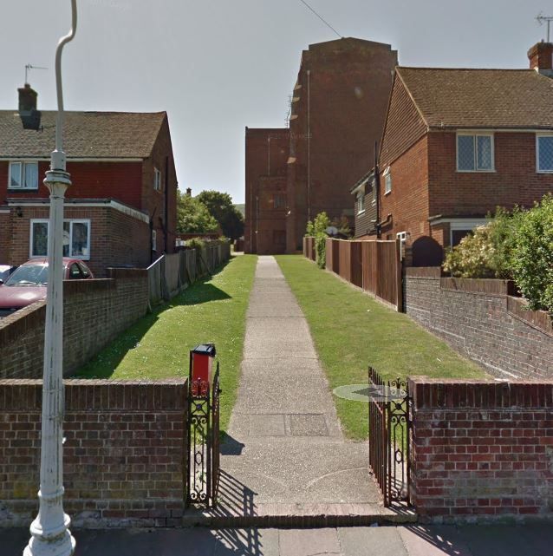
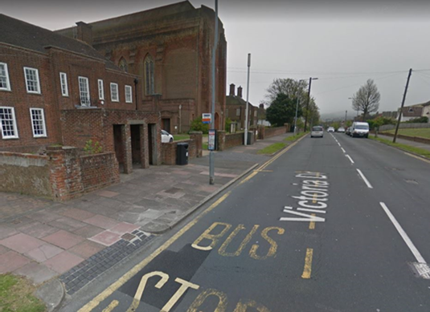
Until the old church was demolished it was possible to walk through the grounds of St Elsabeth’s Church between Victoria Drive and Baldwin Avenue.
We want to make sure that you will still be able to do so when the site is redeveloped and we believe that we can do this by adding the old route to the rights of way map. To do this we need to be able to show that people had been walking through the grounds for the last 20 years before they were closed off.
To do this we need people to fill in forms giving evidence of their use of the path.
A form you can fill in is attached. It asks a number of questions, some of which may seem a bit odd, but are needed for legal reasons. There is also a map for you to show which route you used.
If you know of anyone else who has used the route please let them know about this. You can download more copies of this form from the Beachy Head Ramblers web site at xxxxxxxxxxxxxx

Please return the form to Beachy Head Ramblers at xxxxxxxxxxx. You scan the form and email it to xxxxxxxxxxx, but we do need a signature on the form.
Thank you
Beachy Head Ramblers
Note: A copy of the form you fill in will be kept by the Ramblers for this application only. It will not be used for anything else. It will be passed to East Sussex County Council to process the application to add the route to the map. They might send it to the Planning Inspectorate. The evidence you have provided may be made public (minus any contact details) by the council. The Ramblers will delete their copy of your form when the path is securely on the map. You can see the policy of the county council at htps://www.eastsussex.gov.uk/yourcouncil/about/keydocuments/foi/dataprotection
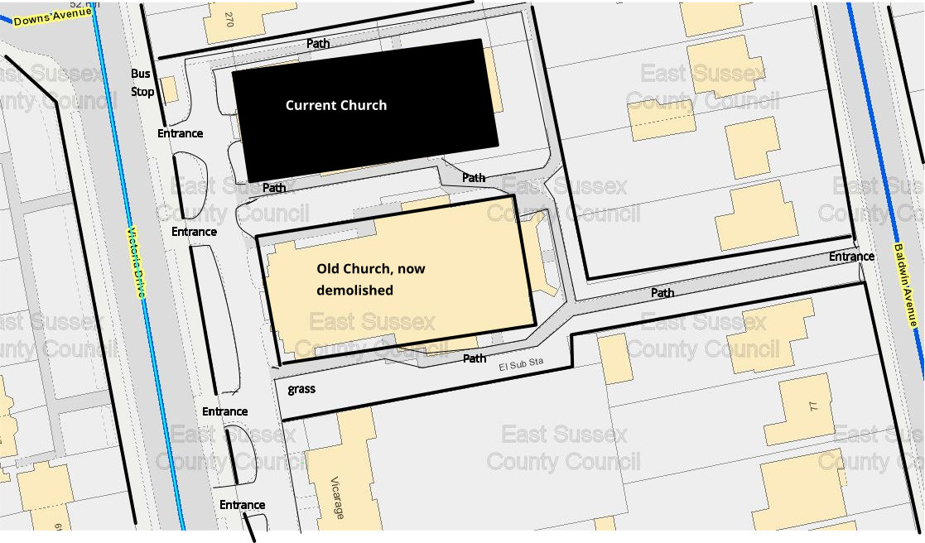
The answers on this form are about paths through St Elisabeth’s Church grounds
Please answer the questions below, deleting any answers that do not apply, or writing in the correct answers. Please answer all questions.
1). Please draw on the map above the route or routes you used.

2). Please give your name (and your age, if under 18)

3). Please give your address

4). If we can contact you with any further enquiries please give contact details here (email preferred:
5a). When did you first start using the route(s) you have drawn on the map?
5b). When did you last use the route(s)?
5c) Were there any significant gaps in time between your first and last use? (for example because you moved away? Yes/No If so when were the gaps?
6). How did you use the route: On foot / other (please describe)
7). How often did/do you use the section of the route? e.g. daily/weekly/monthly. If you drew more than one route please say roughly how often you used each one.
PLEASE TURN OVER
8). What did you use the route for?(for example to get into town, get exercise, walk the dog
get to school, get to the bus stop, visit friends etc.)

19). Have you ever encountered any locked gates, or any similar obstacles?
(If yes, give details below) Yes/No

10). Have you ever seen any notices suggesting that there is no right to use The route on foot? Yes/No
(If YES, give dates and wording below)

11). Have you ever been asked not to use the path on foot? Yes/No
(If yes, give dates and who asked you not to use the path below)

12). Have you ever asked someone for permission to use the path on Yes/No
foot? (If yes, give dates and name of person below)

13 ). In principle, would you be willing to come to an enquiry to talk
about your knowledge of the route? Yes/No

Please use the space below to give any further information requested by the questions above or to tell us anything else that you think might be relevant.

Please sign here…………………………………………….Date………………………….
Please return this form to Beachy Head Ramblers, at xxxxxxxx or email a scanned and signed version to us at xxxxxxxx

APPENDIX 2, EXAMPLE OF A FORM AND LETTER WHERE THE ROUTE HAS NOT CHANGED
DON’T LOSE YOUR WAY GROUP- SUSSEX
Claiming Unregistered Rights of Way
The group includes members of Mid Sussex Bridleways Group, the Open Spaces Society, the Ramblers Association, the Trail Riders Fellowship, and the South Downs Society

Do you walk, cycle or ride on Love Lane, which goes from Winterbourne to Hope in the Valley?

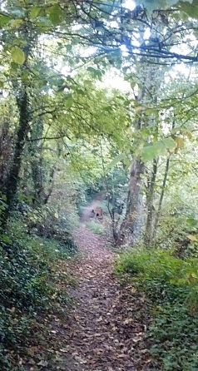
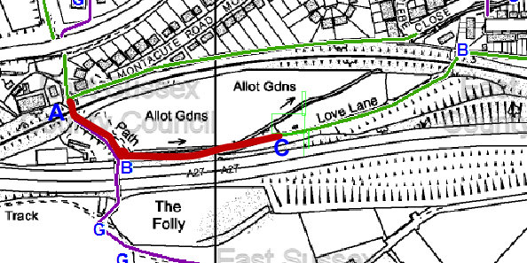
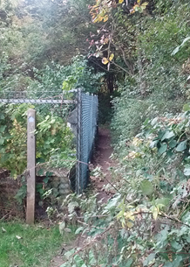
It’s an attractive and well used route. But at the moment the western part, which runs past the allotments, could be closed at any time, if the Highways Agency (who we believe to be the owners) decide to widen the road, or do other works, or simply take against the track.

This is because, for some reason, this part of the route is not on the official map of rights of way or the list of roads maintained by the council, despite the bridleway sign at the west end.

To keep it safe by adding it to the map of rights of way, we need to show that people have used it “as of right” without asking permission or having an individual agreement with the landowner for at least the last 20 years.

We need people who have used the route during that time to give evidence by filling in the attached form. We need evidence from walkers, horse riders and cyclists.

Because people move it is harder to get evidence of use at the start of the period, so we are particularly keen to get evidence of use in the 1990s, but all evidence is very welcome.

If you know of anyone else who has used the route please let them know about this.

Please return the form to Chris Smith (Ramblers Association) at xxxxxxx, or ring me on xxxxxxx and I will collect the form from you.
Thank you

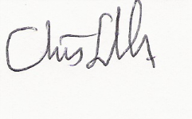
This page is intentionally left blank The reason for doing this is so that the evidence form is all on one sheet, but you need to tell people that you have not just left a page off by mistake
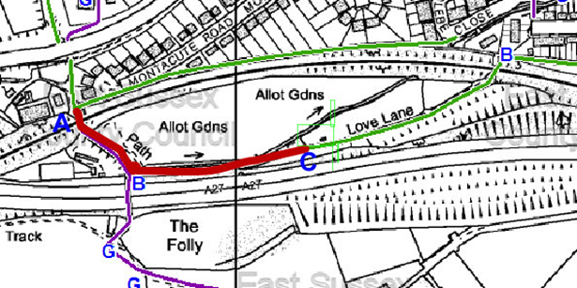
The answers on this form are about a track in Lewes Town which runs from the junction of Bridleways 7a and 7b (539816 109462)south under the railway bridge and then turning in a generally south easterly direction on the south west side of the allotment car park. It then turns south along the west side of the allotments to reach point B (539895 109393). It then turns generally east, running between the stream and the bypass, to reach point C (540075 109414)at the western end of bridleway 8b,.
Please answer the questions below, deleting any answers that do not apply, or writing in the correct answers. Please answer all questions.

1. Please give your name (and your age, if under 18)

2. Please give your address

3. If we can contact you with any further enquiries please give contact details here:

4. During what period have you used the route?
From __________ to Date of signing
(if you no longer use the route cross out “date of signing” and put the date you stopped above)

5. How did you use the route? On foot / On horse / On bicycle

6. How often did/do you use the route? e.g. daily/weekly/monthly (Do not use vague words like ‘occasionally’; try to be as precise as you can) (Do not include any journeys made to a garage you rented)

7. What did you use the route for?(for example to get to town,
Walk the dog exercise the horse, stretch your legs, visit friends etc.)

8. Have you ever encountered any stiles or gates on the route? Yes/No
(If yes, give details below) PLEASE TURN OVER

9. Have you ever seen any notices such as “private”, “no right of way”
“no trespassing” or similar on the route? Yes/No
(If YES, give dates and wording below)

10. Have you ever been employed by or been a tenant of the owner of
the path (believed to be the highways agency)

11. Have you ever been asked not to use the path? Yes/No
(If yes, give dates and who asked you not to use the path below)

12. Have you ever asked someone for permission to use the path? Yes/No
(If yes, give dates and name of person below)

Please use the space below to give any further information requested by the questions above or to tell us anything else that you think might be relevant.

Please sign here…………………………………………….Date………………………….

Please return the form by hand or by post to xxxxxxxxxxxx

APPENDIX 3, AND EVEN SHORTER FORM USED WHERE THE ROUTE IS NOT IN DOUBT
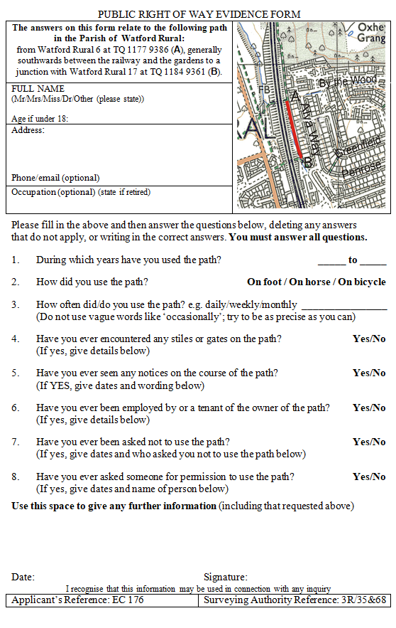
Thanks to Chris Beney for this form.

APPENDIX 4 AN APPLICATION FORM

WILDLIFE AND COUNTRYSIDE ACT 1981
EAST/WEST SUSSEX COUNTY COUNCIL DEFINITIVE MAP AND STATEMENT
To West Sussex County Council of: County Hall, Chichester PO19 1RQ
To East Sussex County Council of County Hall , St Annes Crescent, Lewes BN7 1UE
I, (insert name), for and on behalf of the Ramblers Association, 1 Clink Street, 3rd Floor, London, England, SE1 9DG (delete the whole of this section after your name if applying on your own, insert name and address of your organisation if not the Ramblers) hereby apply for an order under section 53(2) of the Wildlife and Countryside Act 1981 modifying the definitive map and statement for the area by:
Adding a footpath/bridleway/restricted byway (delete as applicable) from…………..(insert starting point including grid reference) to ………. (insert finishing point including grid reference

And shown on the accompanying map (at the bottom of the application insert a map showing the claimed route as accurately as you can. The original map must be at least 1-25,000 (the size of the Ordnance Survey Explorer maps) and you must not reduce it to a smaller size than this when the form is printed out)

I attach copies of the following documentary evidence in support of this application:
Applicant’s statement (if you have written one)
(number) forms showing evidence of use.

Signed dated

The sections in red and italics require action from you. Delete and add as appropriate.
Put the map here. It will probably overflow onto the next page.

APPENDIX 5- A NOTICE THAT YOU CAN USE TO TELL LANDOWNERS ETC.

FORM OF NOTICE OF APPLICATION FOR MODIFICATION ORDER
SECTION 53(5) OF, AND SCHEDULE 14 TO, THE WILDLIFE AND COUNTRYSIDE ACT 1981
(Insert name of council) COUNCIL DEFINITIVE MAP AND STATEMENT

To:
Of

I (your name), for and on behalf of (your organisation, if applicable) hereby give notice that on (insert date you applied) I made application to the (Insert name of council) Council of (insert the council’s address) that the definitive map and statement for the area be modified by;

Adding a (insert the description of the route that you put in the application)

Signed: ……………………………………… Dated …………..

Note- not part of the notice.

This application asserts that there is an existing right of way between these points. Your land may be affected.

Map- not part of the notice

A map of the route applied for is attached.

You do not have to put the material in that is not part of the notice, but it seems a little rude not to include a map at least, otherwise the owner may not know what you are talking about.

APPENDIX 6 A CERTIFICATE OF SERVICE

FORM OF CERTIFICATE OF SERVICE OF NOTICE OF APPLICATION FOR MODIFICATION ORDER

WILDLIFE AND COUNTRYSIDE ACT 1981

(Name of council) COUNCIL DEFINITIVE MAP AND STATEMENT

CERTIFICATE OF SERVICE OF NOTICE OF APPLICATION FOR MODIFICATION ORDER

To: Name of council

of: address of council

I (your name), for and on behalf of (your organisation, if applicable) hereby certify that the requirements of paragraph 2 of Schedule 14 to the Wildlife and Countryside Act 1981 have been complied with.

Signed:

Dated: .

Our reference- you do not have to provide any reference or description, but it seems a good idea to make sure that there can be no doubt about which application you are referring to.

