APPLICANTS STATEMENT

Our reference-

THE APPLICATION ROUTE

(insert map)

Application is being made to add a (insert status) from to

The route is in xxx Parish,.

None of it is currently on the definitive map or statement.

DOCUMENTARY EVIDENCE OF HIGHWAY STATUS

Discovery of Evidence
In order to be able to modify the definitive map and statement, the surveying authority needs to have a discovery of evidence which shows that it can be reasonably alleged that the map and statement are incorrect.
The evidence discovered in this application includes……….

Weighing the Evidence
The courts have given guidance on how evidence of highway status is to be considered. In Fortune and Others v Wiltshire Council and another (2012) EWCA Civ 334 Levinson LJ said, at paragraph 22 “In the nature of things where an enquiry goes back over many year (or, in the case of disputed highways, centuries) direct evidence will often be impossible to find. The fact finding tribunal must draw inferences from circumstantial evidence. The nature of the evidence that the fact finding tribunal may consider in deciding whether or not to draw an inference is almost limitless”. As Pollock CB directed the jury in R v Exall (1866) 4 F & F 922: ‘It has been said that circumstantial evidence is to be considered as a chain, but that is not so, for then, if any one link broke, the chain would fall. It is more like the case of a rope composed of several cord. One strand of the cord might be insufficient to sustain the weight, but three stranded together may be quite of sufficient strength”.
Whilst no single piece of evidence is conclusive, I believe that, taken as a whole, the pieces of evidence demonstrate highway reputation over many years (amend as necessary)

HISTORIC MAPS
Planning Inspectorate consistency guidelines comment on these maps as follows: under "Other post-1800 maps" (page 11) 12.43 "Commercial maps are rarely sufficient in their own right to permit the inference to be drawn that a route is a highway. However, combined with evidence from other sources, they can tip the balance of probability in favour”.

YEAKELL AND GARDNER'S SUSSEX 1778-1783
This map is available on-line as part of the “Old Sussex Mapped” project of the University of Portsmouth at http://www.envf.port.ac.uk/geo/research/historical/webmap/sussexmap/Yeakell_36.htm
WHAT THIS EVIDENCE SHOWS
THE SIGNIFICANCE OF THIS EVIDENCE
The prospectus for this series of maps sets out the aim of covering all of Sussex and showing all public and private roads and all bridleways. These aims were not achieved. Only the southern half of the county was covered and few private roads were shown. (The sheer volume of missed out private roads and tracks can be seen by comparing the number of roads shown on later maps such as the first edition of the ordnance survey 1-2500 series.) The existence of a way on this map means that it was more likely than not, a public route.
The map does not have a key.

GARDENER AND GREAM MAP 1795
This map is held at the East Sussex records office at the Keep under reference AMS 608/1/1/29/17 The map at the Keep does not have a key. The map is also available online on the McMaster University site in two sections. The western section is at https://digitalarchive.mcmaster.ca/islandora/object/macrepo%3A80921 The eastern section is at https://digitalarchive.mcmaster.ca/islandora/object/macrepo%3A80922
WHAT THIS EVIDENCE SHOWS
THE SIGNIFICANCE OF THIS EVIDENCE
Few private roads were shown. (The sheer volume of missed out private roads and tracks can be seen by comparing the number of roads shown on later maps such as the first edition of the ordnance survey 1-2500 series.) The existence of a way on this map means that it was more likely than not, a public route.

FIGG’S MAP OF EAST SUSSEX
This is held by the East Sussex record office at the Keep under reference ACC 3553 The catalogue says
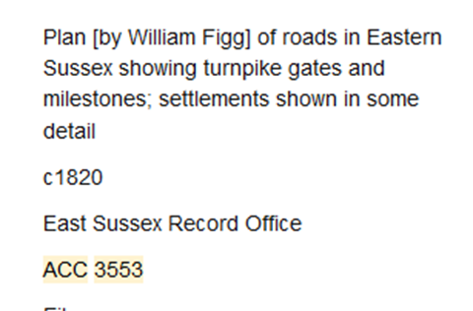
The reference suggests that only public roads were shown.
WHAT THIS EVIDENCE SHOWS
THE SIGNIFICANCE OF THIS EVIDENCE

GREENWOOD AND GREENWOOD MAP OF SUSSEX 1825
This map is held at the Keep under reference AMS 6008/1/129
WHAT THIS EVIDENCE SHOWS
THE SIGNIFICANCE OF THIS EVIDENCE
The map has a key, which is shown below
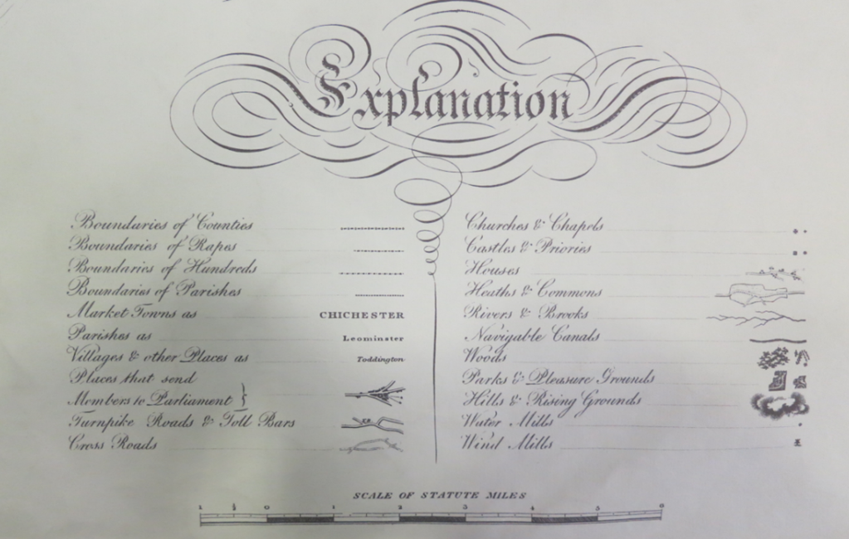
A close up of the key explains how roads were depicted. (See below)
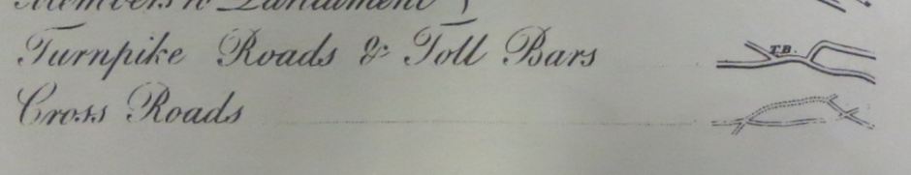
Paragraph 2.24 of the Planning Inspectorate’s constancy guidelines says “In modern usage, the term “cross road”/“crossroads” is generally taken to mean the point where two roads cross. However, old maps and documents may attach a different meaning to the term. These include a highway running between, and joining, other highways, a byway and a road that joined regional centres.
Few private roads were shown. (The sheer volume of missed out private roads and tracks can be seen by comparing the number of roads shown on later maps such as the first edition of the ordnance survey 1-2500 series.) The existence of a way on this map means that it was more likely than not, a public route.

MUDGES MAP (UPDATED TO 1873 BUT BASED ON A SURVEY OF 1813)
The map is held at the Keep as part of the Brighton Pavilion collection under reference BHM000009. The map at the Keep does not have a key.
WHAT THIS EVIDENCE SHOWS
THE SIGNIFICANCE OF THIS EVIDENCE
Few private roads were shown. (The sheer volume of missed out private roads and tracks can be seen by comparing the number of roads shown on later maps such as the first edition of the ordnance survey 1-2500 series.) The existence of a way on this tracks means that it was more likely than not, a public route.

FIRST EDITION OF THE ORDNANCE SURVEY 1” MAP
Copies of the first edition of these maps can be found at the University of Portsmouth web site at https://www.visionofbritain.org.uk/ and the National Library of Australia at https://nla.gov.au/nla.obj-231917049/view
The maps for Sussex were first published between 1813 and 1819.
Copies of the instructions given about the portrayal of private roads are given in correspondence held at the national archive under reference OS 3/260. The instruction given is “as these plans are intended for military purposes no existing roads should be omitted; but to distinguish those roads which are entirely on trespass the line of the main road from which they branch is not to be broken for them”
THE EVIDENCE PRESENTED BELOW
This evidence is taken from the University of Portsmouth/ National Library of Australia.
WHAT THIS EVIDENCE SHOWS
THE SIGNIFICANCE OF THIS EVIDENCE

TURNPIKE PLANS
Organisations wishing to build turnpikes were required to show the owners of all the land within a certain distance of the proposed turnpike, and to place this information on deposit so that it could be inspected by the public and objections made, before Parliament would give the powers needed for the road’s construction. Records were well researched as mistakes would have been costly with the possibility of the private bill being thrown out and a rival organisation being given permission.
THE EVIDENCE PRESENTED BELOW
WHAT THIS EVIDENCE SHOWS
There are no turnpike plans relevant to this application.
THE SIGNIFICANCE OF THIS EVIDENCE

INCLOSURE RECORDS
THE EVIDENCE PRESENTED BELOW
WHAT THIS EVIDENCE SHOWS
The application route does not appear to be covered by any inclosure. order
THE SIGNIFICANCE OF THIS EVIDENCE

TITHE RECORDS
The Tithe Commutation Act of 1836 enabled tithes to be converted into a monetary payment system. Maps were drawn up to show the tithe-able land in order to assess the amount of money to be paid.
The tithe process received a high level of publicity as landowners would be particularly keen not to be assessed for more tithe payment than necessary. No-titheable land deemed to be unproductive was usually excluded from the process. It is common therefore for no tithe to be payable on roads, although wide grass drovers roads could carry a tithe as they were used as pasture. It was in the interest of landowners for untithed roads to be shown correctly to minimise their payments. Footpaths and bridleways were more likely to be at least partially productive (for example as pasture). Therefore, although the process was not directly concerned with rights of way, inferences can be drawn from tithe documents regarding the existence of public rights, and in particular, public vehicular rights. In some cases highways are coloured in yellow or sienna to indicate public status.
Tithe maps can be accessed at the National Archive in black and white. The maps have been digitalised by the Genealogist web site at https://www.thegenealogist.co.uk/search/advanced/landowner/tithe-records/ . Tithe maps and apportionments for East Sussex are also available on line at https://apps.eastsussex.gov.uk/leisureandtourism/localandfamilyhistory/tithemaps/
I have taken screen shots to show how the route is displayed and of any relevant apportionments.
THE EVIDENCE PRESENTED BELOW
This evidence is taken from the Genealogist site.
WHAT THIS EVIDENCE SHOWS
THE SIGNIFICANCE OF THIS EVIDENCE
The case Dunlop v secretary of state for the environment and Cambridgeshire County council CO/1560/94 decided by by Mr Justice Sedley ruled that Tithe map evidence is that the ways coloured brown can only be public ways (presumably this also applies to non-tithed routes where this colouring was not used). The decision is controversial. Nevertheless it makes case law which is binding on decision makers until overturned.

RAILWAY, CANAL AND RIVER RECORDS
Companies wishing to build railways or canals were required to show the owners of all the land within a certain distance of the proposed railway, and to place this information on deposit so that it could be inspected by the public and objections made, before Parliament would give the powers needed for the railway’s construction. Records were well researched as mistakes would have been costly with the possibility of the private bill being thrown out and a rival company being given permission
There do not appear to be any railway canal or river records relevant to this application.
THE EVIDENCE PRESENTED BELOW
WHAT THIS EVIDENCE SHOWS
THE SIGNIFICANCE OF THIS EVIDENCE

FIRST EDITION OF THE ORDANCE SURVEY 25 INCH TO THE MILE MAP
It is often said that the disclaimer on the early OS maps means that they are not evidence of public rights. This is not the case. Whilst before the 1950s it is not possible to say “It is on the OS map therefore it is a right of way”, earlier OS maps provide evidence from which inferences can be drawn. For example, if a route is over a single landowner’s land and leads only to a barn on that land, it can be inferred that this route was probably private. But if a route goes from one public highway to another and crosses the land of a number of owners or occupants or a number of occupants were dependent on the way to access their land then, in the absence of evidence of private rights or wayleaves, it can be inferred that public rights are likely to exist. Such evidence is unlikely to be conclusive on its own, but taken with other evidence, may support the existence of public rights on the balance of probabilities.
In addition, after observing that the Courts have determined OS maps are not evidence of the status of a way, the Planning Inspectorate Consistency Guidelines say at Section 12, page 9 & 10
“12.35 Nevertheless, the inclusion of a route on a series of OS maps can be useful evidence in helping to determine the status of a route, particularly when used in conjunction with other evidence (Section 2.16 to 2.21 'Evidential Weight' refers)”
And contemporary wisdom was that the disclaimer on the early OS maps was simply to avoid the potential of litigation, as declared in The Countryside Companion (1948 page 320):
“In practice the qualifying statement of the Ordnance Survey may be regarded as a safeguarding clause to absolve them from being involved in any footpath litigation.....A path which is shown, may, however, generally be presumed public.”
. Whilst Ordnance Survey surveyors were instructed not to investigate public status the Instructions to Ordnance Survey Field Examiners 1905 is clear in its direction that:
“Mere convenience footpaths for the use of a household, cottage or farm; or for the temporary use of workmen, should not be shown; but paths leading to any well-defined object of use or interest, as to a public well, should be shown. N.B. – A clearly marked track on the ground is not in itself sufficient to justify showing a path, unless it is in obvious use by the public”
The early maps in the first edition series contain valuable extra information when cross referenced to the books of reference that were published with them. These are indexed by parish. There are also books showing the derivation of names shown on the map and surveys of parish boundaries
Copies of the first edition of the Ordnance Survey 25 inches to the mile maps could formerly be found online at https://www.old-maps.co.uk/#/
I have copied extracts showing the route map from this source.
THE EVIDENCE PRESENTED BELOW
WHAT THIS EVIDENCE SHOWS
THE SIGNIFICANCE OF THIS EVIDENCE
Planning Inspectorate consistency guidelines say at Section 14 paragraph 14.2.35(After observing that the Courts have determined OS maps are not evidence of the status of a way): Nevertheless, the inclusion of a route on a series of OS maps can be useful evidence in helping to determine the status of a route, particularly when used in conjunction with other evidence (Section 2.16 to 2.21 'Evidential Weight' refers)".

BOOKS OF REFERENCE/AREA BOOKS
Area books accompanied the first edition maps contain land use information. Parcels of land were numbered on the maps and the reference book can be used to determine land use.
THE EVIDENCE PRESENTED BELOW
WHAT THIS EVIDENCE SHOWS
THE SIGNIFICANCE OF THIS EVIDENCE

BOUNDARY REMARK BOOKS
The Ordnance Survey was given the duty of ascertaining and recording all public boundaries by the Ordnance Survey Act 1841. The OS boundary Remark Books, held at the National Archives in series OS 26, are the results of the Ordnance Survey’s checking of the boundaries with the meresmen from the parish on each side.
THE EVIDENCE PRESENTED BELOW
WHAT THIS EVIDENCE SHOWS
THE SIGNIFICANCE OF THIS EVIDENCE

OBJECT NAME BOOKS
The Ordnance Survey needed a reliable way of determining the names put on their maps. They recorded the authority for the names and the modes of spelling. Normally only persons of repute were approached to authenticate a name, to avoid local vernacular names.
THE EVIDENCE PRESENTED BELOW
WHAT THIS EVIDENCE SHOWS
THE SIGNIFICANCE OF THIS EVIDENCE

THE ADCOCK MAP AND SURVEY FOR WEST SUSSEX
According to the survey report held at West Sussex Records Office under the reference WDC/SU18/1/10, on the 26th February 1890 West Sussex County Council instructed its surveyor, Mr Adcock, to survey parish roads. The County had been formed in 1889 and it seems to have wanted to improve minor roads in its area.
Parishes were then the highway authority for all roads other than main roads. The survey was to divide these roads into classes according to the amount of traffic they carried and to report on their condition. Parish Roads were divided into five classes. The purpose of conducting the survey was so that the County Council could consider making grants to parishes to maintain the roads, subject to their being brought up to and maintained by the parish at a standard suitable for the traffic.
Bridleways and footpaths appear to have been omitted.
The report says that all lengths given are approximate.
Here is how the application route is described in the survey.
A MAP
There is a map held at the West Sussex archive under reference WDC/SU18/1/11. The catalogue entry says “Map of West Sussex Highways” and “endorsed ‘Adcocks Plan’ when first catalogued- this endorsement is now missing”. It is in black and white, and does not differentiate between various categories of highway, which is not what you would expect from a map to accompany the Adcock survey.
Here is how the application route is shown on the map
THE SIGNIFICANCE OF THIS EVIDENCE
If this is the map relating to the Adcock survey the portrayal of roads on it is evidence of public highway status.
A FURTHER MAP
I have a map which was sent to me by a person I cannot now contact. It is described as being the plan accompanying this survey.
It is labelled “County Surveyor’s Report 1890
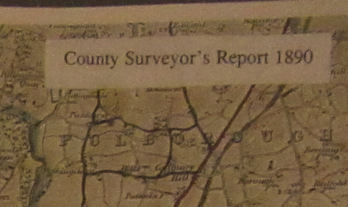
This is how the application route is shown on the map.
THE SIGNIFICANCE OF THIS EVIDENCE as a whole
I suggest that it is likely that the surveyor would first have approached the parish councils to find out what roads they saw themselves as responsible for. It is possible that some parishes left out some roads they did not want to admit as their responsibility, but it is highly likely that the County would have checked carefully that no roads were included that were not the responsibility of the parishes, since it was considering making grants to the parishes. These grants and the maintenance of the roads by the parishes would have been ultra-vires if the routes were not public highways.

HIGHWAY HANDOVER MAP
THE EVIDENCE PRESENTED BELOW
Following a freedom of Information request to provide any highway maps it held for the 1890s, West Sussex County Council provided a copy of a map which showed various roads in different colours The map is dated 1894 so is most likely to be a “handover map” showing which roads were being handed over from the parish councils to the district councils to maintain. The council did not provide a reference. Here is the email which accompanied the map.
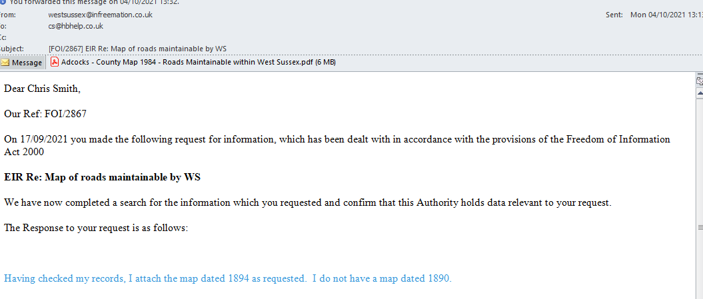
Despite the heading on the attachment I do not believe that this is the Adcock map because of the date. A copy can be obtained from the County Council by quoting the reference on the email.
The key shows the colours of the various roads as follows:
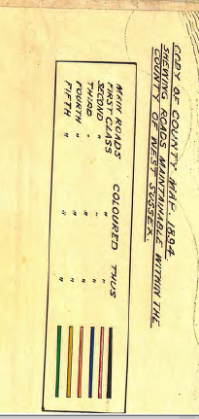
Since this map and the Adcock survey are so close together and use the same highway classification, I suggest that they can be considered together
WHAT THIS EVIDENCE SHOWS
THE SIGNIFICANCE OF THIS EVIDENCE
I suggest that it is likely that the surveyor would first have approached the parish councils to find out what roads they saw themselves as responsible for. It is possible that some parishes left out some roads they did not want to admit as their responsibility, but it is highly likely that the County would have checked carefully that no roads were included that were not the responsibility of the parishes, since it was considering making grants to the parishes. These grants and the maintenance of the roads by the parishes would have been ultra-vires if the routes were not public highways.
When the time came for the parishes to hand over their responsibility to the district councils those districts would also check carefully what they were taking on.

PARISH AND ESTATE MAPS
These maps are of use because the show how the parish or the landowner viewed routes within the parish at the time the maps were compiled.
There appear to be no such maps relevant to this application
THE EVIDENCE PRESENTED BELOW
WHAT THIS EVIDENCE SHOWS
THE SIGNIFICANCE OF THIS EVIDENCE

QUARTER SESSIONS RECORDS
Highway functions were discharged by Justices of the Peace in Quarter Sessions before powers were handed over to what are now the highway authorities. Court records provide conclusive proof of the matters on which decisions were made.
THE EVIDENCE PRESENTED BELOW
WHAT THIS EVIDENCE SHOWS
THE SIGNIFICANCE OF THIS EVIDENCE

HIGHWAY AUTHORITY MINUTES and other records
In East Sussex the majority of roads and other ways were the responsibility of the Parish up to 1894. From 1894 the responsibility passed to district councils, with an important exception that main roads could be made the responsibility of the county. In 1930 East Sussex county council became the highway authority for roads and other ways. However district councils were delegated to continue to manage local roads and rights of way until 1934.
THE EVIDENCE PRESENTED BELOW
WHAT THIS EVIDENCE SHOWS
THE SIGNIFICANCE OF THIS EVIDENCE

INLAND REVENUE VALUATION
The Finance (1909-10) Act 1910 provided for land valuations to take place across the country so that the increase in its value could be taxed. Deductions from the assessable value could be claimed by landowners where the land was crossed by a footpath or bridleway. Where a vehicular highway crossed land, it was often omitted from the valuation, and shown on the Inland Revenue’s plans as a “white road”. If a route were a private vehicular way, then it could be developed, increase in value and so be taxed. Accordingly, private tracks were not usually excluded from the assessable hereditaments.
Of these records, the PINS Definitive Map Orders Consistency Guidelines states under the heading “Exclusion of a route on the map record” at para. 11.7 “…. So if a route in dispute is external to any numbered hereditament, there is a strong possibility that it was considered a public highway, normally but not necessarily vehicular….”
THE EVIDENCE PRESENTED BELOW
WHAT THIS EVIDENCE SHOWS
THE SIGNIFICANCE OF THIS EVIDENCE
Where a route is shown as a “white road” the overwhelming likelihood is that it was a public road. There are a few other possibilities, (for example the land was a waste of no value) but they are so rare that I suggest that the onus of proof is on any party wishing to put forward an alternative explanation.

FIELD BOOKS
    - The Inland Revenue created Field Books for calculating the value of each numbered hereditament on the map. Where rights of way crossed a hereditament the landowner could (but was not obliged to) claim for a reduction in value on account of this. A deduction made for rights of way in a field book is evidence of the existence of rights of way, but the lack of a deduction may only be evidence that the landowner chose not to make a claim.
THE EVIDENCE PRESENTED BELOW
WHAT THIS EVIDENCE SHOWS
THE SIGNIFICANCE OF THIS EVIDENCE

BOWEN MAP OF WEST SUSSEX HIGHWAYS
In 1915 the County Engineer and Surveyor, H.W. Bowen, produced a map of roads with the classification shown below
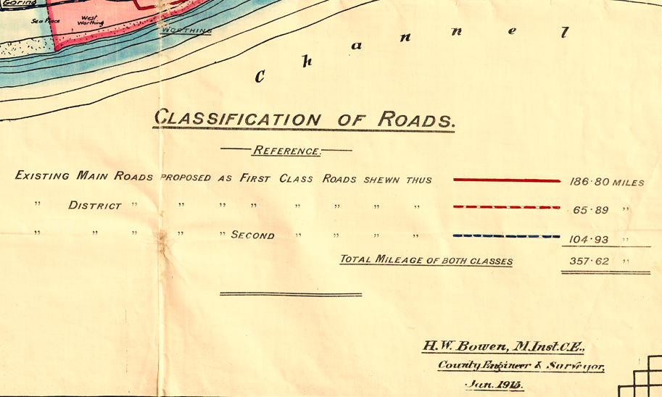
I have been told that the map was produced for the purposes of classifying carriageways as a means to securing funding from road tax, via the Development and Road Improvement Funds Act 1909. It does not appear to show all roads, particularly in urban areas. For extract for Steyning below shows far few roads than Ordnance Survey maps of the time. There are a number of roads shown only by single black lines, which are not classified on the key.
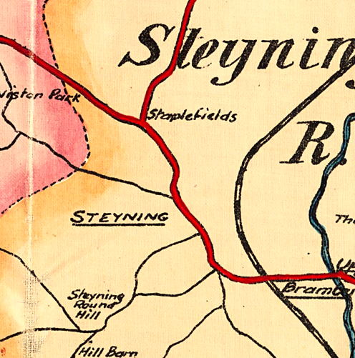
WHAT THIS EVIDENCE SHOWS
THE SIGNIFICANCE OF THIS EVIDENCE
The appearance of a road on this map is supportive of the view that the road was, at the time, a public road.

OTHER MAPS
The National Library of Scotland has a number of maps covering the application route at . xxxxxxx
THE EVIDENCE PRESENTED BELOW
WHAT THIS EVIDENCE SHOWS
THE SIGNIFICANCE OF THIS EVIDENCE

THE HANDOVER OF RESPONSIBILITY FOR HIGHWAYS
    - In 1930 responsibility for minor roads passed from district councils to county councils. However until 1934 East Sussex delegated responsibility for these roads back to the district councils. District Councils prepared handover maps and schedules showing the roads that they were responsible for and for which the county council would now take over responsibility. The application route was in the xxxxxx Rural District Council area at the time.
    - WHAT THIS EVIDENCE SHOWS
    - THE SIGNIFICANCE OF THIS EVIDENCE

THE 1932 RIGHTS OF WAY ACT SURVEY
    - The 1932 Rights of Way Act enabled councils to draw up maps of rights of way if they wished to do so. District Councils were responsible for this. The process was limited to recording what parish councils thought were the rights of way in their area and whether or not landowners admitted their existence.
    - No differentiation was made between footpaths and bridleways.
    - There is no key, but it appears that routes agreed with landowners were shown in sepia whilst those not agreed by landowners were shown in blue.
    - The map made as part of this process is held at the West Sussex Records Office under reference AM 796/13/4 The excerpt below is taken from that map
    - WHAT THIS EVIDENCE SHOWS
    - THE SIGNIFICANCE OF THIS EVIDENCE

1ST DEFINITIVE MAP SURVEY
I have been involved in researching lost rights of way in East Sussex for some time. As a result I have examined the bulk of the documents currently available about the creation of the first definitive map.
At an early stage I agreed to examine and catalogue all of the digital records held by the rights of way team at ESCC. This was in return for access to those documents. For each parish the team has had digitalised all the correspondence now existing between the county, the parish and others, the Ramblers surveys, the observations on the parish schedules by the County and the draft statement. The main material missing is the schedules drawn up by the parishes, which has not yet been digitalised by the county. In order to catalogue the records it was necessary to read each one
Although I was not able to catalogue all of the material, I did manage to catalogue about 2/3 of it, which gave me a fairly clear idea about what went on. I have subsequently looked at quite a lot of the material that I was not able to catalogue.
I have also examined:
- All of the maps held at the East Sussex Records Office which were drawn up by the parishes as the initial part of the survey
- 22 schedules drawn up by the parishes
- All of the minutes of the rights of way committee (which dealt with all objections, with detailed reports in most cases by the clerk)
- About 25 folders held at the East Sussex Records Office containing nearly all the material about individual objections.
- The first draft definitive map for the whole of Sussex (apart from the area around Rye, which is missing from the record at the Record Office)
- The first definitive maps for Battle rural , Chailey, Hailsham, Lewes and Uckfield rural councils.
From these documents it is possible to get a very clear picture of what went on and what documents were and were not examined
A large amount of material from the surveying of the first definitive maps survives in East Sussex, both in the records of the rights of way team and at the East Sussex Archive at the Keep. In most cases it is possible to see the initial maps drawn up by the parishes, the forms filled in by the parish, the survey conducted by members of the Ramblers or other organisations, the first draft definitive maps, the minutes of the relevant county council sub-committee and the first definitive map. Correspondence between the county, district councils and the parish also survives in many cases, as do many of the notes of those county officers charged with examining inclosure and quarter sessions records. This means that it is possible to see what was and what was not examined and taken into account.
The surveys took account of local knowledge, the 1932 rights of way surveys (mostly now lost) and also inclosure and quarter sessions records (although some were missed) It appears that examination of deposited plans and tithe records was inconsistent. Tithe maps were not routinely consulted. They would sometimes be examined where there was a dispute.
There does not appear to have been any examination of plans for railway lines that were not built, nor any examination of subsequent plans for modifications after initial construction.
No account was taken of inland revenue records, which were not then available, and there appears that older maps were only consulted in some contentious cases. Council minute books do not appear to have been examined. Nor do early private or Ordnance Survey maps appear to have been consulted except in the odd case. In many cases, where a land owner objected the route was simply dropped. This is perhaps not surprising when the council was trying to get through over 2,000 miles of alleged rights of way.
THE EVIDENCE PRESENTED BELOW
WHAT THIS EVIDENCE SHOWS
THE SIGNIFICANCE OF THIS EVIDENCE

CURRENT OWNERSHIP
Insert here any information that may be relevant, such as the fact that land on either side of the route is registered, but the application route is not, which suggests that it may be a highway and not owned by the frontagers.

THE ONLINE MAP OF MAINTAINABLE STREETS
Both East and West Sussex Councils maintain online maps of streets that they are responsible for maintaining. The West Sussex map can be found at https://www.westsussex.gov.uk/planning/local-land-charges/local-land-charges-map/ The East Sussex Map can be found at https://escc.maps.arcgis.com/apps/webappviewer/index.html?id=f1ebafa02f6746a39a693e7ead3ff1fb
THE EVIDENCE PRESENTED BELOW
The evidence below is taken from this source.
WHAT THIS EVIDENCE SHOWS
THE SIGNIFICANCE OF THIS EVIDENCE
If there were no public rights over the route it would normally be outside the council’s powers to maintain it. The portrayal of the route on this map is therefore evidence of the existence of public rights.

THE CHARACTER OF THE ROUTE TODAY
The photographs below illustrate the character of the route today
THE EVIDENCE PRESENTED BELOW
The photos below were taken by me on The photos below are taken from Google Streetview
WHAT THIS EVIDENCE SHOWS
THE SIGNIFICANCE OF THIS EVIDENCE

CONCLUSION
Whilst no single piece of evidence is conclusive, I believe that, take as a whole, the pieces of evidence demonstrate the existence of a highway over many years. There are possible, if often unlikely, alternative explanations for each individual piece of evidence shows but, I suggest, no explanation other than the existence of a right of way which explains what all of these pieces of evidence show.
The test at this stage is only “Can it reasonably be argued that the right of way exists as suggested”.
The later test at confirmation of any order is “Is it more likely than not that the right of way exists as suggested”.
I believe this application passes both of those tests.

REQUEST
I request the surveying authority to add the route to the definitive map as a footpath/bridleway/byway
I request the opportunity to respond to any comments made on this application.

APPENDICES

